Student Name: Phi Hung Cao

Student ID: 300279621

I confirm that my program is complete and working. I have implemented all required features

CSIS3540 Client SERVER SYStem

Lab7: Recursive Power Calculation

Source Code:

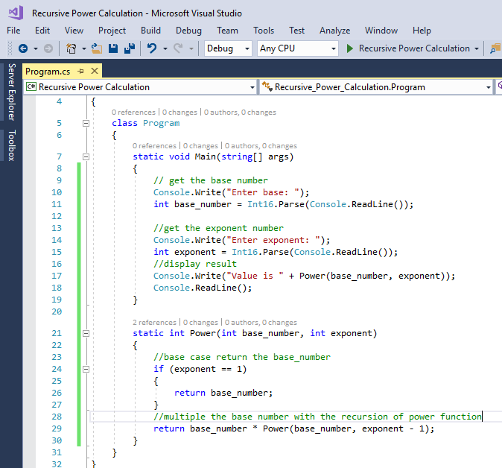

Output:

